DECEMBER 6, 2020

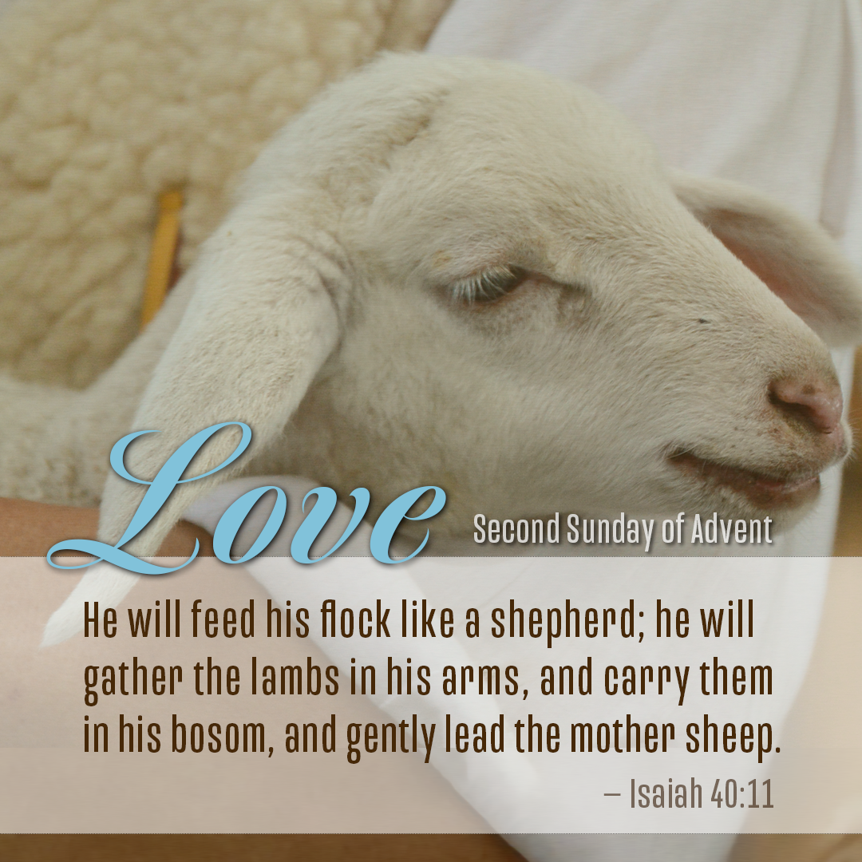
PRELUDE – Becki Smith
WELCOME – Welcome to Scott Memorial United Methodist Church. It is always a privilege to join in unity with children of God to praise and worship our Savior. Let us prepare ourselves for what God has for us this day. May we rejoice in knowing that each one in this place has been called to live as children of light. May we build one another up as we share God’s word this day.
ANNOUNCEMENTS – If you have prayer requests, please email them to us at scottmemorialumc@hotmail.com or call the church at 740-942-2825.
Bible Study - We are continuing our Advent Bible Study titled - Faithful -by Adam Hamilton – we are planning to meet at two times – on Tuesdays at 10:30 am and on Wednesdays – at 7:00 pm. Both can be attended either in-person or utilizing Zoom. If you would like to be included on Zoom, please call the church at 740-942-2825 and give us your email address to receive the invitation to the Zoom meeting. Remember, you do not need to be a member of the church to participate!
Volunteers needed– If you would like to volunteer to be a reader for our Advent readings during the next two weeks please see me following the service, leave a message at the church, text the pastor, or email the church. I thank you in advance for answering the call!
IF HARRISON COUNTY MOVES FROM ORANGE TO RED, WE WILL MOVE TO TOTALLY ONLINE WITH ALL EVENTS – (NO IN-PERSON WORSHIP)
CHRISTMAS EVE – CELEBRATE WITH US: If we are still orange, we will hold an in-person service at 5:30 in the sanctuary, if we are red there will be no service indoors. We will hold a parking lot service Christmas Eve at 7:00 pm regardless of the rating.
CALL TO WORSHIP - based on Isaiah 40 by Hans Holznagel
We are continuing our method of call and response again this week. After each sentence that I say, you all can repeat: Let us worship God! Let us worship God!
Lift up your voice. Lift it up, do not fear. Let us worship God!
Feeding, gathering, carrying, leading: this is how God will come. Let us worship God!
The old will pass away. A new world will down. Let us worship God!
Love, faithfulness, righteousness, peace: these will mark God’s new day. Let us worship God!
Love needs a path. Peace needs a highway. Let us worship God!
Even as we wait, let us make a way for God. Let us worship God!
Even now, in our hearts and in our world. Let us worship God!

LIGHTING OF THE ADVENT CANDLE
Reader One: Our lists are long, even in this strange mess where we live these days. And we want to do it right, we want to be safe, but we want to be able to enjoy the season. We’ve got work to do to put right what has gone wrong, to heal what is broken, to mend the relationships, and to prepare for the company that will come.
Reader Two: The prophet Isaiah reminded us that there is work to be done. “Prepare the way of the Lord, make straight in the desert a highway for our God.” When God comes in, then healing is to be found, but we need to make the way; we need to open the door into our lives.
Reader One: So, we light these candles as a sign of our faith that the God we worship is not far from us and that we can clear the way for that God to come and dwell with us. We light these candles in faith that company is coming. (Light a purple and the pink candle)
Reader Two: O Come, O Come Emmanuel.
PRAYER –
God, we are confident of your love and in your coming again, bringing a world where all will be made right. Calm our anxiety, strengthen our patience, and keep our hope aflame, as we work towards, and wait for, a new day. Lord of life, we come to you consumed by our worry and our pain. When we blame you for not being there in our need, forgive us. When we turn away from you in moments of loss, guide us back to your faithful arms. We long to put our faith in your promised healing. We ask for healings and blessings for those names mentioned and unmentioned this day. We yearn to believe that you are the resurrection and the life. Teach us once more, Merciful One, that you weep, when we weep, and rejoice as we search to find our way home. In this Advent season, O God, restore us and make us anew. We pray our worship, and our gifts help us prepare the way for the Good News to be proclaimed, for people to be comforted, and for the earth to be tended. Through our giving, may all partake of an abundant yield of peace. We pray and believe it to be so. We thank you this day for your powerful teachings. Be with us this day as we pray together the prayer you taught us.
Our Father, who art in heaven, hallowed be your name. Thy kingdom come; thy will be done on earth as it is in heaven. Give us this day our daily bread. And forgive us our trespasses, as we forgive those who trespass against us. Lead us not into temptation but deliver us from evil. For thine is the kingdom, the power, and the glory forever. Amen.
SCRIPTURE – ISAIAH 40: 1-11
REFLECTION – “Gentle Shepherd” Becki Smith
MESSAGE – BECAUSE OF GOD’S LOVE
When God called the Jewish people, he gave them everything necessary to follow Him and for salvation, principally, the Law. When they entered the Holy Land, God warned the Jewish people not to intermarry with the Gentile and to always keep God first. They did for a while but as the generations passed, the Jews were continually tempted by the Gentiles and their gods around them. Perhaps a key decision indicating the direction of the Jews away from god was when in the face of the looming threats all around them, they cried out for a king when God was already their king. So, God sent judges, but judges were not enough. Then God sent the prophets to call people back to Him, but their warnings went unheeded. Even when Josiah recalled the people to God and rededicated the nation and people to God, it was short lived. Finally, their rebellion was too much, and God realized there had to be another way.
When Nebuchadnezzar defeated Jerusalem in 597 BC, he deported more than 10,000 Jews to the city of Babylon, the capital of the Chaldean Empire in what is now modern-day Iraq. They took the most prominent, educated, and skilled citizens of Judah. The deported Jews formed their own community in Babylon and retained their religion, and practices. They could farm and perform other sorts of labor to make a living. They married, built homes, had children, and settled in because Jeremiah told them they would be there for 70 years. Despite all of this, exile was difficult as they now found themselves separated from their home, the Temple, their land, and God because God was viewed as tied to the Holy Land. The Hebrew faith was built on the promise that God would protect the Hebrews and use them for His purposes in human history. Questions of why and how God could allow this to happen and whether God had abandoned them were prevalent. They were forced to question their understanding of and relationship to God and what it means to be a faithful and obedient Jew. Perhaps the most difficult and painful lesson they learned in exile is that it was their own rebellion which brought the judgment of God upon them, as the prophets had continually warned. As the years rolled by, a spirit of despair and hopelessness fell upon them.
After several decades, a follower of Isaiah rose to speak a message of hope to the exiles: their punishment is almost done, and God is now preparing the way for them to return home. They ended up returning in three waves one under Zerubbabel in 535 B.C., Ezra in 458 B.C., and Nehemiah in 444 B.C. They rebuilt Jerusalem, its Temple, its walls, their homes, and their lives. There was a renewed commitment to the faith, the study of the Scriptures and leading holy lives, separated from the influence of the Gentiles. But after a generation or two, they wandered from the path again.
And God saw the need for a new path to guide and redeem His people. But despite all of this, in the four hundred years prior to Jesus’ birth, there was utter silence from God. No books of the Bible were written, no prophets were raised up, Israel continued to be under foreign rule and God did not intervene in history. In the Jewish faith, God is what God does and when God is silent and is not acting on behalf of His chosen people, it leads one to ask, “Why?” Times were difficult. Babylonian rule gave way to Persian rule which gave way to Greek rule and finally the worst of all, Roman Rule. It was during this time of occupation that Israel’s hope for a Messiah began to increase. The more difficult life was, the more people yearned, watched, and prayed for the Messiah to come. They continued to faithfully wait without answers. The hope for a Messiah was not something new. Isaiah writes in the 8th century BC: “For unto us a child is born, unto us a son is given: and the government shall be upon his shoulder: and his name shall be called Wonderful, Counselor, The mighty God, The everlasting Father, The Prince of Peace. Of the increase of his government and peace there shall be no end, upon the throne of David, and upon his kingdom, to order it, and to establish it with judgment and with justice from henceforth even forever.” And so, they waited and prayed and cried out to God. Slowly their hope for a better day today gave way to a better day tomorrow and extended further and further into the future as God was silent. Or was He?
And what we find is that the words of Second Isaiah begin to take on new life as His message speaks to the generations after the exiles. Though none can see it, God is working behind the scenes and through the course of history to prepare the way for the coming of the Messiah, setting the earthly stage for the entry of His only begotten Son into the world. How? First is the Greek language. Alexander the Great rose to power in 336 BC and in just 13 years conquered most of the Middle East and Northern Africa, including Israel. Alexander loved Greek culture and saw it as a key to uniting all the different peoples and nations now under his rule by having a common culture and language. This allowed Jews and Christians to communicate the Good News to anyone in the Empire. But even more so, Greek was the perfect language to communicate the Good News as it can communicate the conceptual and philosophical ideas of the Gospel. The Hebrew language was no longer suitable to convey God’s new work in Jesus Christ because it was a functional language focusing action and doing and not the philosophical and theological. Through Alexander and the Greek empire, God set in place the language of the Good News and eventually, the language of the New Testament as the OT was translated into Greek by diaspora Jews. When Paul quotes Scripture in his ministry, he is not quoting the Hebrew Bible but the Greek Old Testament.
In 141 BC, Judas Maccabee led a revolt and Israel gained its first independence in more than 6 centuries. But in 63 BC, the Roman Empire conquered Israel. This was a dark and oppressive time; Roman occupation was viewed as the equivalent of the kingdom of evil ruling the land. Life was harder and more difficult than it had ever been under Roman rule. James Carol, author of “Constantine’s Sword”, describes the Roman Empire as “The world first totalitarian regime” asserting that the Jews experienced “the most grievous violence against the Jewish people until Hitler’s attempt at a Final Solution.” But despite that, the Roman Empire provided many of the catalysts which would enable the Good News to spread and lead to dramatic growth of the church. The Roman Empire may seem the greatest enemy of early Christianity, and at times a bitter persecutor, yet it was in many ways the grandest preparation and in some ways the best ally of Christianity. It was used by God to prepare the way of the Lord reminding us of Proverbs 16:4 “The Lord has made everything for his own purposes, even the wicked for a day of disaster.” The irony of all this is mind boggling. While the Jewish nation was chafing under Roman rule, with many crying out for the Messiah to come and deliver them, God was at work using the Roman Empire to prepare the earth for the coming of His Son. This led to five contributions of the Roman Empire to the spread of the Gospel.
First was Roman peace. The world had not been at peace since the days of Alexander the Great three centuries earlier. The Roman Empire united Greeks, Romans, and Jews all under one government and brought peace where there had been dissension and fighting. Peace allowed the Good News to spread and the church to flourish.
Second was diaspora Judaism. The term diaspora means scattering. The exile of Jews to Babylon started this movement of Jews outside of Israel. The diaspora really increased in Roman times. Strabo, a Greek geographer of the late first century, B.C., says that you cannot go anywhere in the civilized world without encountering a Jew. By the middle of the first century, there are probably more Jews living outside of Israel, than living in Judah proper, resulting in major Jewish communities in most of the large cities of the Empire. Christianity spread among the Jews because they were the first target in Jerusalem, Judea, and the diaspora. The synagogue, the central place of study, worship and community for diaspora Jews was the first place Paul and others started preaching the Good News and not only gave them a home base but a familiar group of people to whom to begin ministry.
Third is the Roman highways. Rome built an extensive system of more than 30,000 miles of roads throughout its Empire to move troops around quickly and to facilitate trade where Rome made much of its money. Roman roads were famed for being straight and well made. Some still exist to this day. The roads knit the Roman Empire together and made it safer to travel as they had soldiers posted every mile. These roads greatly facilitated the spread of the Gospel and the community amongst Christian believers in different towns. They also provided relatively easy access to large numbers of people to which to share the Gospel.
Fourth is the Roman postal system. These highways also facilitated quick and reliable communication through the Empire. The emperor Augustus, who reigned from 27 B.C. to A.D. 14, established Rome’s first official postal service to communicate reliably as well as rapidly with the help of his numerous governors and military officials. Thus, when Paul and other Christians needed to communicate or disciple from afar, they could use the postal system and be assured that their letters would arrive.
Fifth is religious freedom. Rome was the first empire to allow the people it conquered to maintain their gods and their religions. Rome was polytheistic and had 3 main Roman gods: Jupiter who watches over the Roman state, Juno who was the god of women and Minerva who was the god of wisdom and sponsor of arts, trade, and strategy. When Rome conquered a people, it would adopt their major gods which grew to a list of 15. This openness to other gods and faiths greatly favored the growth of Christianity and spread of the Gospel. If a faith was not a danger to public morality or to the peace of society, they were allowed to spread unchecked under the eyes of the state. This allowed a strange sect which proclaimed a Jew as Messiah who was raised from the dead to spread without fear of reprisal.
Sixth is Caesar Augustus. Augustus had a successful and long reign as Caesar, ending 100 years of civil war and achieving over 40 years of internal peace and prosperity. He expanded the Roman Empire to become far more than a collection of countries. Instead, it became a diverse society and enormous marketplace in which people across Europe, north Africa and the Middle East could trade and travel under Rome’s protection. Now the Greeks believed that gods came down and became a man and intermingled with us, and this belief was adopted Rome as well. When Augustus died in 14 CE, the Senate declared him a god. The idea that a man could become a god opened the door to the idea of Jesus as a man who was God, setting the stage for the Roman people to accept the Good News of Jesus Christ more readily.
And so, in this brief view of history, we see that God’s love has been at work during these 400 years of silence. God used Alexander the Great and even the evil Roman Empire to prepare the way for the coming Messiah, even when Israel thought God was silent. When you look at the three centuries of history and what was accomplished through these Empires and how God used them and prepared the way for His Son, we can now more fully understand what Paul meant when he spoke of “the fullness of time ” for everything was now in place for the birth and expansion of the mission of Christ and the Kingdom of God.
There are three questions for us today:
First, what, or how is God working at a higher level or even behind the scenes to accomplish God’s will in your life? How has God been preparing the way to do a new, totally unpredictable and life changing thing?
Second, has God been giving you the silent treatment recently? Silence is often God’s prescription for those times when we are having difficulty listening, when we are so preoccupied with our own issues that we don’t hear, or can’t take time to listen to God’s “still small voice.” As painful as it sometimes can be, silence can be a blessing, the significance of which we may not comprehend. Solitude and silence provide opportunity to reflect, to listen, to regain our perspective, and to refocus on who God is, God’s will and God’s ways. That is something desperately needed in the rush and noise of the Christmas and holiday season. Sometimes God uses enforced periods of silence, both for our benefit and God’s glory. Often, God does this to get our attention (again). Many times, it is an opportunity when God can draw us closer once again, so that we can more clearly hear God’s voice.
How are you going to respond to God’s love? How are you preparing the way for you and others this Advent to receive the Christ child and God’s new work for your life this Advent?
COMMUNION –
The Light of the world is among us.
Yes, he is.
The Spirit has seasoned us.
We lift our lives and our voices in justice and praise.
Praise our Triune God with me!
Honor and glory and wisdom and might are yours forever!
Honor and glory and wisdom and might are yours, Holy Triune God, Life-Speaker, Lawgiver,
Deliverer, Savior, and Lord of all. Your love illumines the universe. Your infinity multiplies the colors, sounds, smells, textures, and tastes with joys that fill our senses beyond all overflowing.
The diversity of your radiance exceeds all knowing. In awe and love we join our voices with angels and saints, martyrs, and cherubim, with those who came before us, and the generations that will follow, in words ancient and ever new:
Holy, Holy, Holy. Lord God of every power, the universe declares your glory from everlasting to everlasting. Hosanna in the highest!
Blessed is Christ who has come in your name.
Hosanna in the highest!
Pure brightness of the Ever living One, Jesus Christ, holy and blessed, to you we turn,
before you we bow, behind you we follow, with you we go into the world, salt and light,
fulfilling your law of love toward God and neighbor, family, and stranger, enemy and friend.
Lead us, light the way Lord.
You have taught us the way of love in your life, in your death, and in your rising.
And you have shown us such love in the meal you first shared with your disciples on the night you were betrayed.
You took bread and blessed it, broke it and gave it to them, saying, “This is my body broken for you. Do this to remember me”.
You took the cup of wine and gave thanks, then passed it to them, saying: “This is my blood for a new covenant that delivers the world from the power of sin and death. Do this to remember me”.
Obeying his command, Triune God, and looking for his return at the last day, we offer here ourselves, with this bread and this cup, our sacrifice of praise and thanksgiving for all you have done and will do to save us. Receive our prayers, our gifts, and us.
Even so, come, Holy Spirit, upon us and these gifts. Make them be for us a sharing in Christ’s body and blood, and make us, receiving them, his body for the world. And make us one: One with you, with each other, in ministry and mission to the world, and in joyful anticipation of that day when we shall feast at the heavenly banquet of Christ’s final victory. We give you all the praise and glory, Holy God, Source, Sustenance and Crown of All, now and forever.
This is my body, take this now and eat. This is my blood, drink from this, each one of you.
PRAYER – Holy God, we are confident in your return, bringing a world that all will be made right. Keep our hope aflame with your love as we await the day when we will be together forever. Amen.
POSTLUDE – “O Come, O Come, Emmanuel” Becki Smith
BENEDICTION – Live in such a way that you await and hasten the coming day of God- - The day of love and faithfulness, the day of righteousness and peace. Go now in the confidence that all things are possible. Amen.

